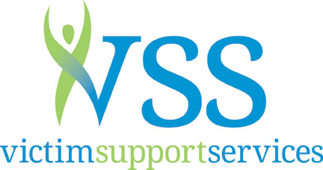

SPONSORSHIP for Voices of Victims Annual Luncheon

Edward D. Hansen Conference Center-2000 Hewitt Ave. Everett

April 8, 2020 at Noon

Event Sponsor: $5,000
Link from Victim Support Services web site and recognition on social media
Recognition in all event promotional materials and publications
Live recognition at event and on Screen
Logo and name on program and table tents at the event
Head table for 10 at the event

Healing Sponsor: $2,500
Link from Victim Support Services website and recognition on social media
Recognition in all event promotional materials and publications
Live recognition at event and on Screen
Logo and name on program and table tents at the event
Priority table for 10 at the event

Resilience Sponsor: $1000
Link from Victim Support Services website and recognition on social media
Recognition in all event promotional materials and publications
Live recognition at event and on Screen
Logo and name on program and table tents at the event
Priority table for 10 at the event

Table Sponsor: $350
A table for 10 so you can have lunch at our event with your friends or colleagues
Your name or business logo on the table

Yes, I want to sponsor Victim Support Services. | Total Amount: | $

My Check is enclosed payable to Victim Support Services: ☐

Please charge my: Visa ☐ MasterCard ☐ American Express ☐
Name on Card:
Card #: |  |  | Expiration Date: | MM/YYYY

Organization:
Contact Name:
Address:
City: |  |  |  |  |  |  | State: |  |  | Zip:
Phone: |  |  |  |  |  |  |  | Fax:
Email: |  |  |  |  |  |  | URL:

If you would like to make an in-kind sponsorship, please describe:

Please return to:
Anne Anderson, Executive Director, Victim Support Services
PO Box 1949, Everett, WA 98206
Email: anne@victimsupportservices.org, Office: 425 252 6081
www.victimsupportservices.org

